EXPERIMENT-11
AIM:
To Change Hardware compatibility of a VM (Either by clone/create new one) which is already created and configured.
PROCEDURE:
STEP 1: GO TO VM WARE WORKSTATION.
STEP2: RIGHT CLICK THE VM AND GOTO THE SETTINGS.
STEP 3: ADD HARDWARE WIZARD AND SELECT SCSI AND CLICK NEXT.
STEP 4: CREATE NEW VIRTUAL DISK.
STEP 5: SELCT THE DISK SIZE AS 2.0. AND SELCT SPLIT VIRTUAL DISK INTO MULTIFILES.
STEP 6: GIVE NAME AND CLICK THE FINISH.

IMPLEMENTATION:
STEP 1: GO TO VM WARE WORKSTATION

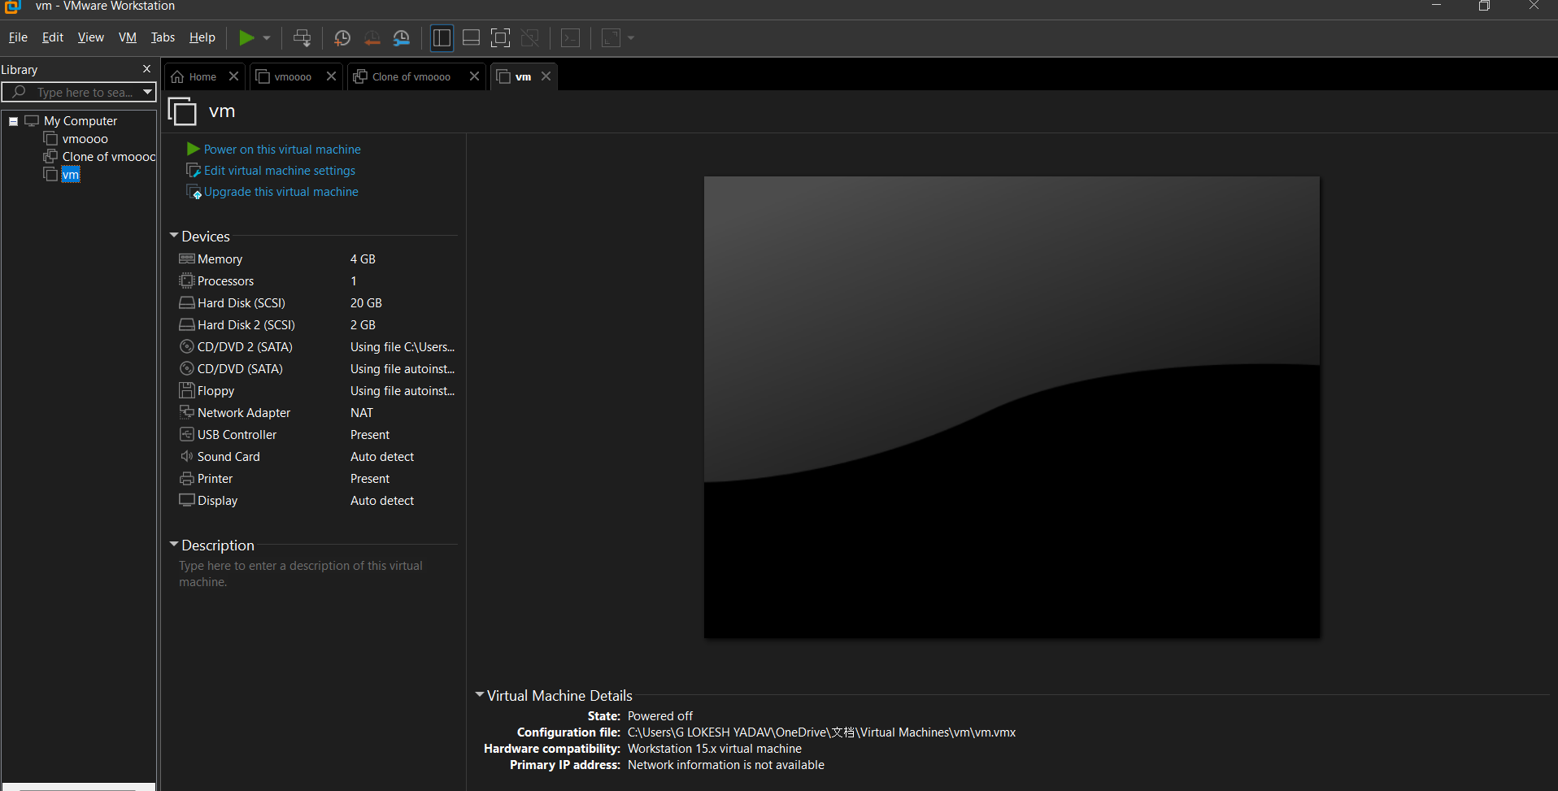

STEP2: RIGHT CLICK THE VM AND GOTO THE SETTINGS
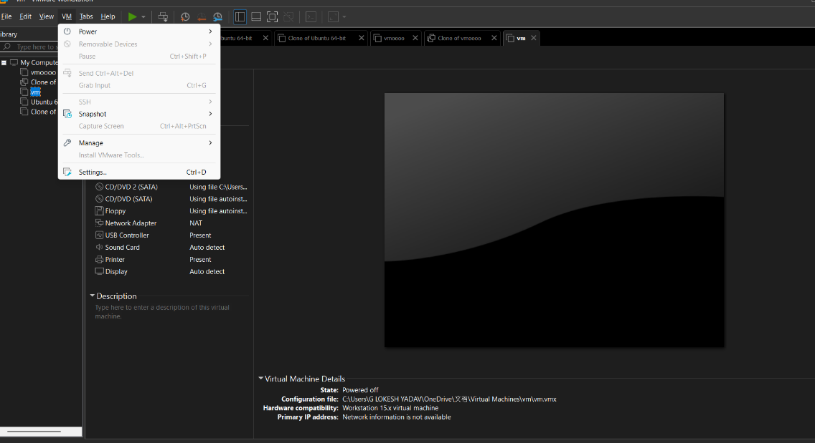

STEP 3: ADD HARDWARE WIZARD AND SELECT SCSI AND CLICK NEXT
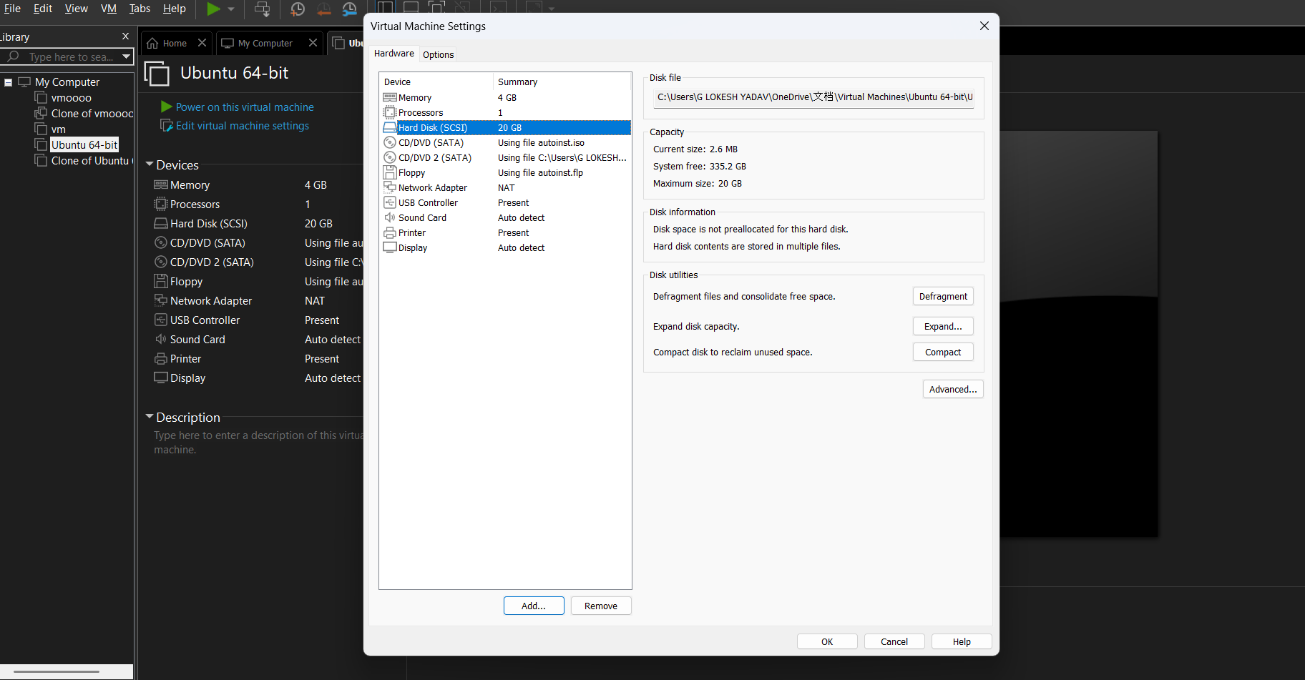
STEP 4: CREATE NEW VIRTUAL DISK
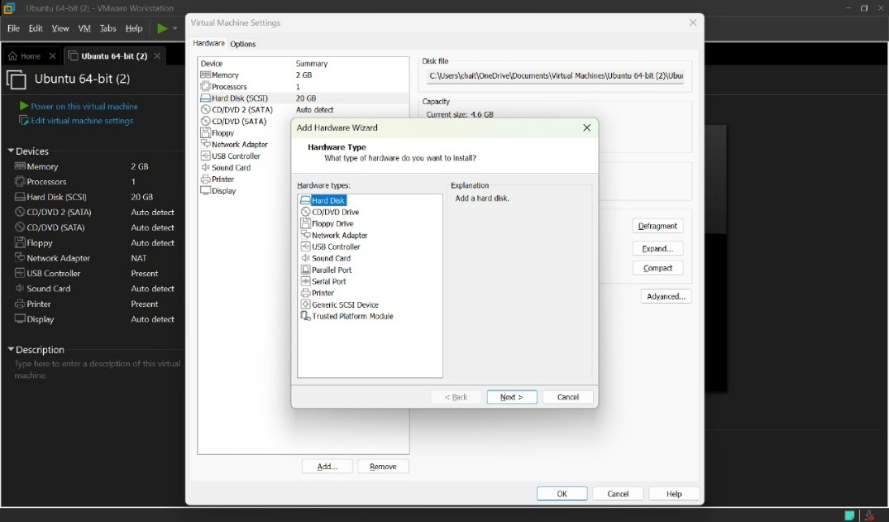
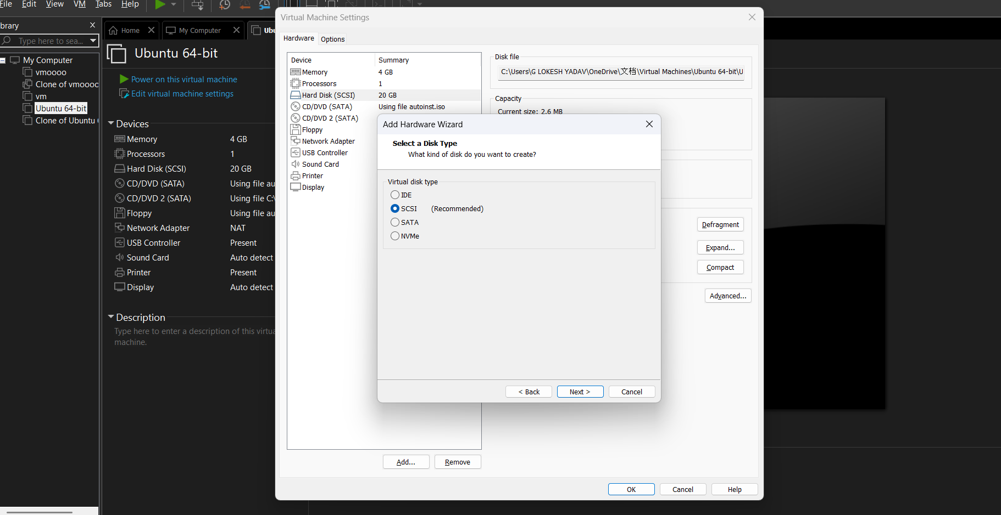
STEP 5: SELCT THE DISK SIZE AS 2.0. AND SELCT SPLIT VIRTUAL DISK INTO MULTIFILES.
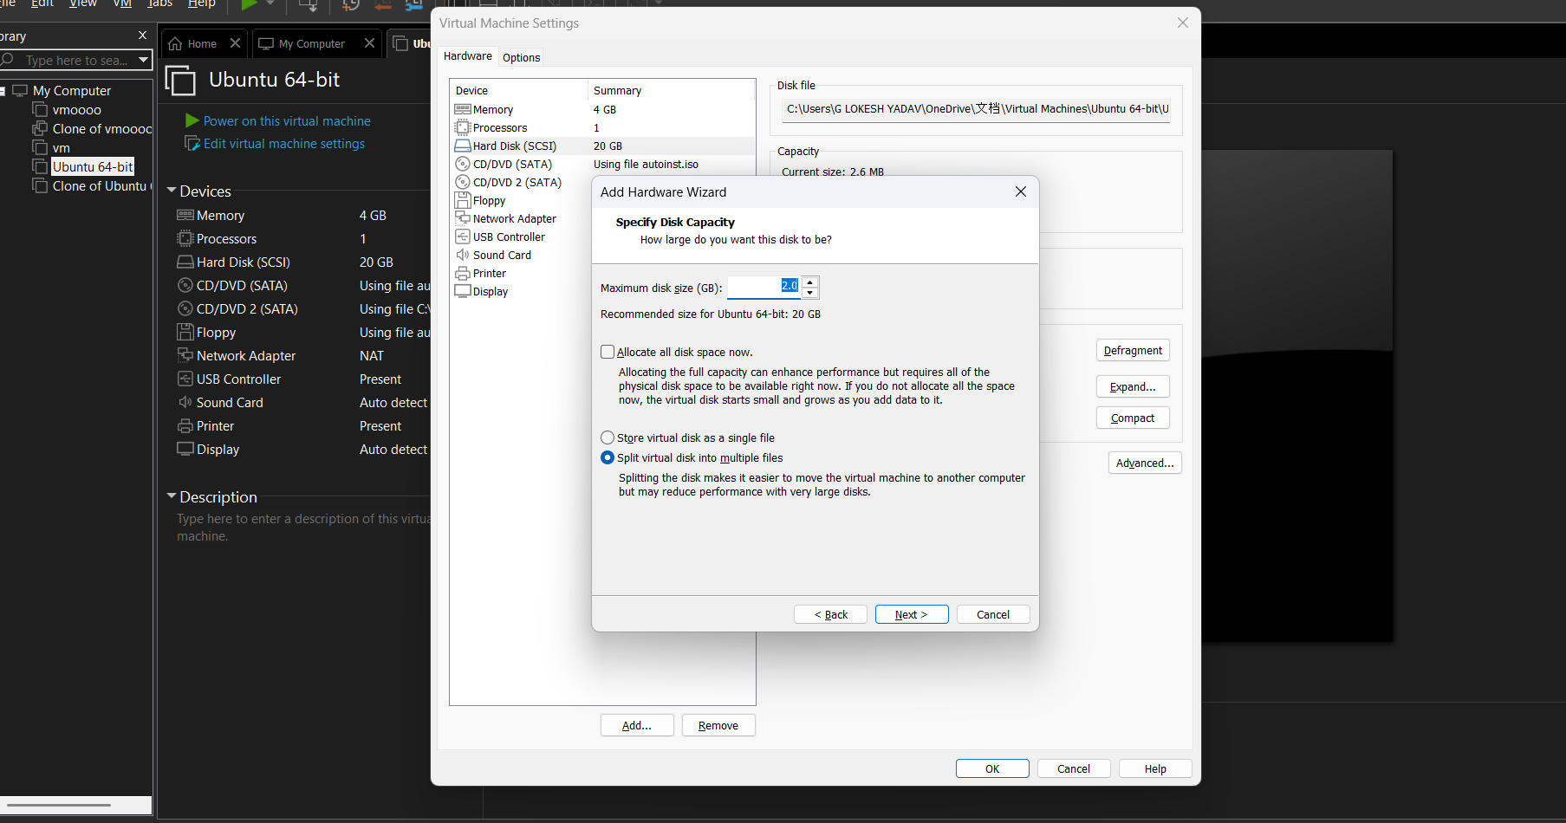
STEP 6: GIVE NAME AND CLICK THE FINISH
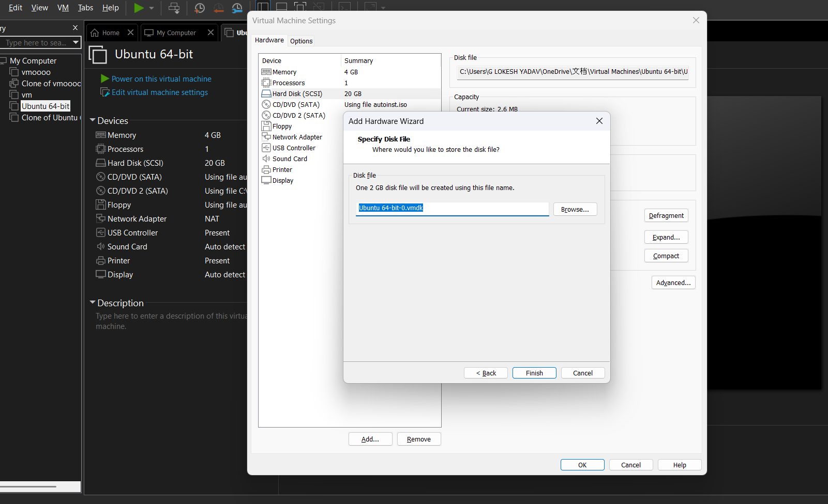
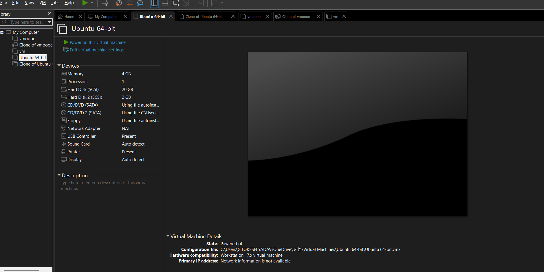
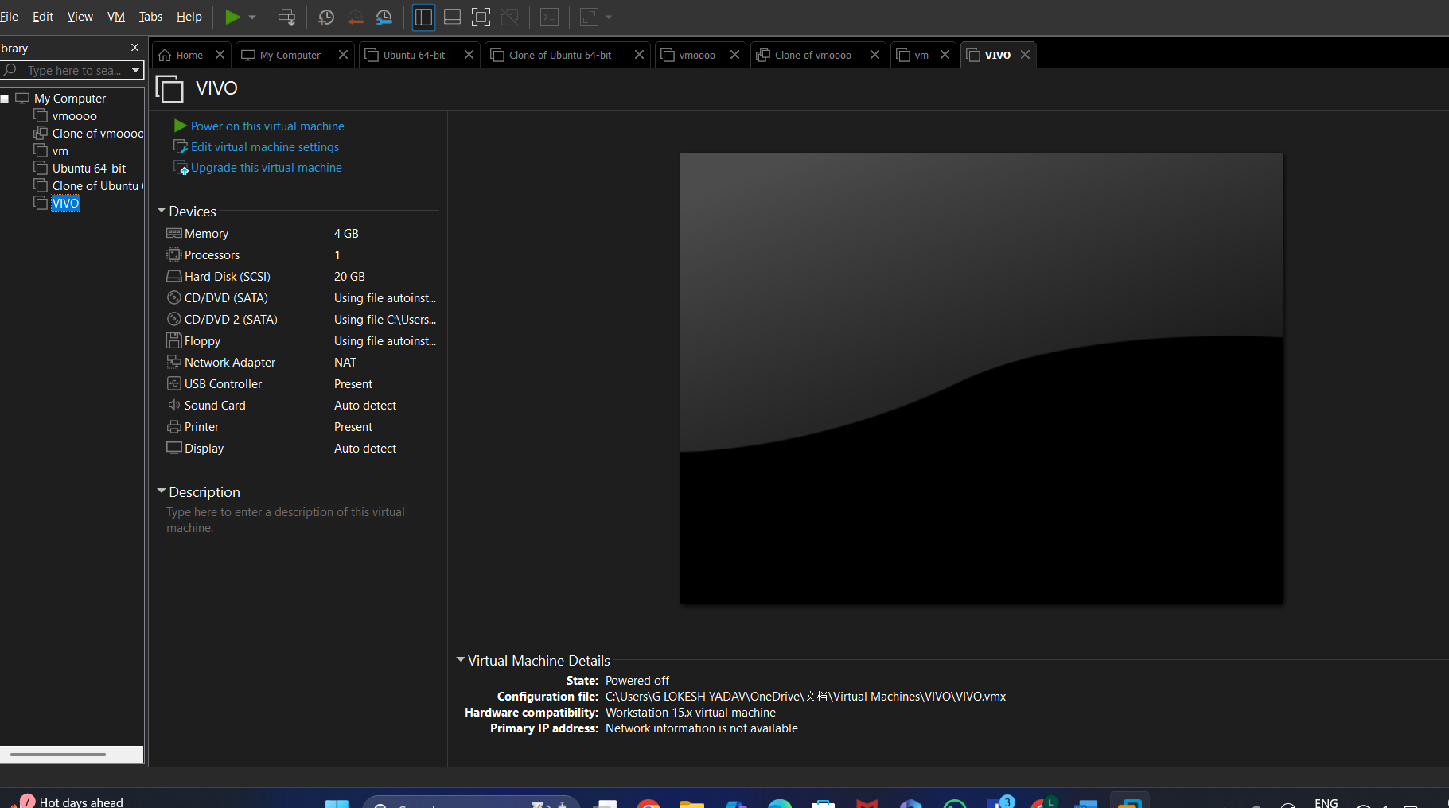

RESULTS; successfully Changed Hardware compatibility of a VM (Either by clone/create new one) which is already created and configured.

